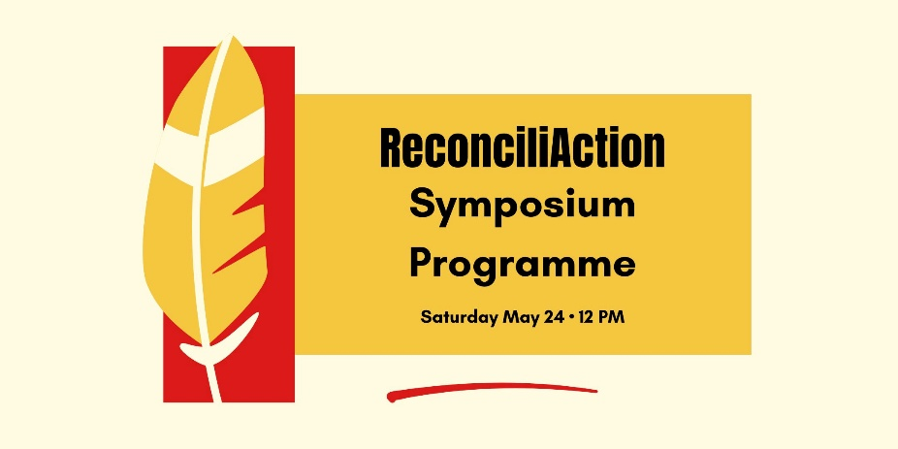
11:30 Doors Open
11:30 Food and beverages offered
12:05 Welcome by Pamela Thomson
Prayer by Rosalyn Kantlaht’ant Elm (Six Nations)
12:30 Sandra Campbell (Wahta Mohawk First Nation and Wolf Clan) opens with a Smudge Ceremony and an Honour Song. Sandra is the Indigenous Outreach Coordinator, Toronto Urban Native Ministry.
12:40 Pamela offers a trigger warning and introduces Douglas Sinclair
Douglas Sinclair (Peguis First Nation) is the publisher of Indigenous Watchdog. The title of his talk is: “What is the status of Reconciliation in May 2025?
1:45 Break – Pamela thanks Douglas
2:05 Pamela introduces Douglas Sanderson
Douglas Amo Binashii Sanderson (Opaskwayak Cree Nation), U of T law professor and Visiting Indigenous Scholar at the Church of the Redeemer, will speak on “Settlers and First Peoples: Reconciliation is fine. But what happened to justice?”
3:15 Break – Pamela will thank Douglas and describe the handout of the Calls to Action and other information we have available
3:35 Pamela introduces Rosalyn Elm
The Ven. Rosalyn Kantla’tant Elm, Director of Indigenous Ministries, The Anglican Church of Canada will lead with a prayer, summarize some of the points made today, and lead a discussion and Q&A
4:30 Rosalyn will thank everyone for coming
Sandra will sing the Travelling Song.
Conversation until 5:00

